Giordana Roma
Opto-electronic Engineer
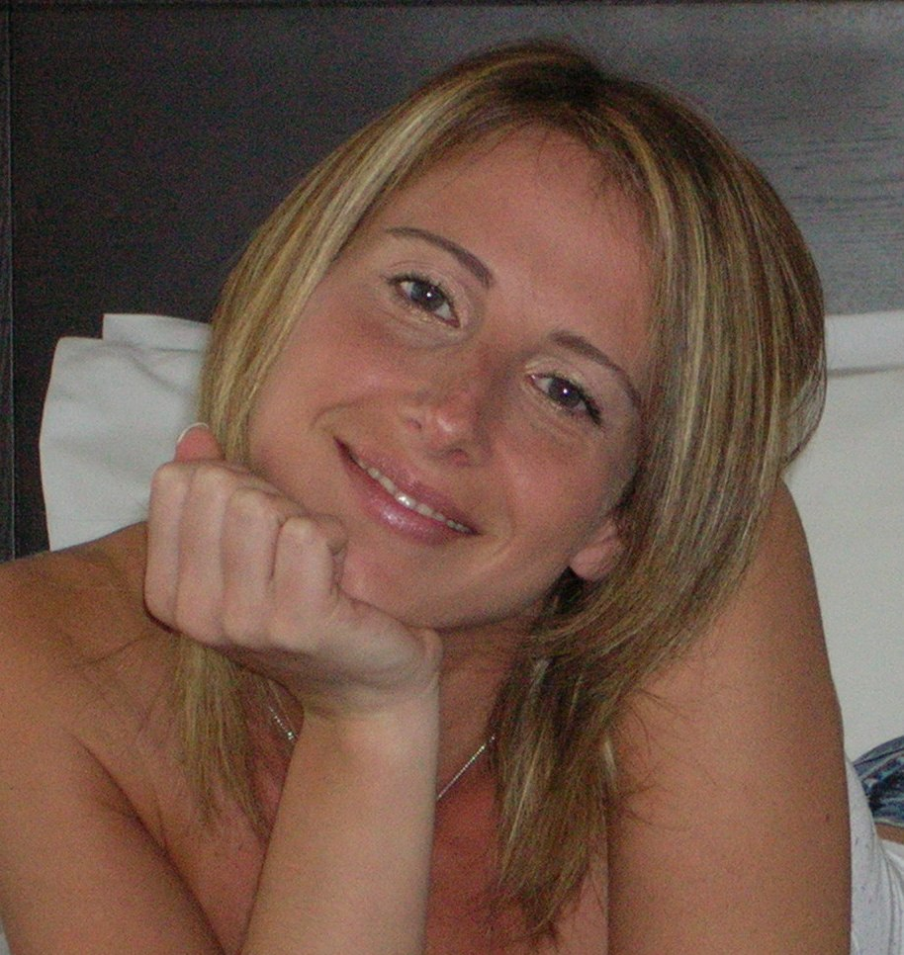

Address: Via B. LUCCHESE 19 • Rome • 00146 • ITALY
MOBILE PHONE: +393405084072
E-MAIL: giordana.roma@gmail.com

Personal informations
- Nationality: Italian
- Birth place and date: Rome, 6th January 1976
Studies

Jun 04 | Qualifying examination for practicing Engineer profession.
Apr 04 | “Laurea” in Electronic Engineering (5 years course) got at University of Rome “La Sapienza” (equivalent to M.Eng with project)  Capabilities: Opto-Electronic.  Degree project:: “Project, realization and characterization of organic LED diodes for high emission efficiency”  Mark:105/110
Jul 95 | Scientific Diploma got at “Plinio Seniore” institute of Rome.  Mark: 51/60
training activities

Dec 04 – Feb 05 | Programming class funded by Accenture Technology Solutions
Jun 03 – Feb 04 | Collaborating with Dr. R.M. Montereali group at the “Laboratory of  Spectroscopy and e Solid State Laser” in ENEA institute of Frascati, for organic film deposition by means of thermal evaporation.  Skills: Experience of vacuum systems
Jen 03– Apr 04 | Collaborating with Prof. F. Michelotti group at the “Laboratory of  Molecular Photonic” in University of Rome “La Sapienza”, for current vs. voltage, luminous power vs. voltage, emission spectrum vs. voltage characteristics of organic light emitting diode and planning of hybrid organic/inorganic microcavity.
It skills

- Programming language:
C, Java, SQL, Matlab, MathCAD, Pascal, LabView.
- Operative System:
Windows 95/98/XP, Unix.
- Application programs:
Main Windows and Office applications (Word, Excel, PowerPoint, FrontPage), Corel Draw, Easy Plot.
WORKING Experiences

From Jul 07 | Opto-electronic Engineer for Electronic Engineering Department at University of Rome “Tor Vergata”, working on C.H.O.S.E. (Center for Hybrid and Organic Solar Energy) research project. The project is focused on hybrid and organic photovoltaic cells development and production cycle.  Skills: making and optimizing of DSSC (Dye sensitized solar cell) to complete a full photovoltaic panel as a re-newable energy source development; planning of organic photovoltaic panel production and reliability; efficiency measurement and computing.
Feb 07 – Apr 07 | Preparation of a major events for small groups in Melbourne (Australia)
Feb 06– Feb 07 | Opto-electronic Engineer for “NeMO” Laboratory (New Material for Optoelectronics) at University of Rome “Tor Vergata”.  Planning, setting-up and execution of experiments and measurements of optical systems, devices and components.  Skills: making and optimizing of channel waveguides embedded for optical modulators using for high speed telecommunication; pure optical TCL networks fulfillment and stability planning; multilayer structures light emission computing. These structures will be integrated in embedded one-shot devices used for biological analysis.
Nov 05–Feb 06 | European Fellowship financed by project EU “Odeon” (design and fabrication of Optoelectronics DEvices based on innovative second-order nonlinear Organic Nanomaterial) to assemble organic and organic/inorganic electro-optical modulators for fast telecommunications, carried out in “NeMO” (New Material for Optoelectronics) Laboratory at University of Rome “Tor Vergata”.  Skills: fulfillment and marketing analysis of a measurement set-up used to calculate transmission losses for channel waveguides structures; guided emission analysis in planar waveguides realized by sol-gel technique.
Jul 05 – Nov05 | Consultant at ITALTEL site for Product Test, Integration and Global Integration area.  Skills: PVV and PQR tests for TELECOM Italia and BELGACOM area based on UDB architecture solution.
Apr 05 – Nov05 | Employed in ACCENTURE Workforce Solutions at Broadband Delivery Center (BDC) site in Rome  Skills: product specifications analysis and management of internal test and software bugs related to products services based on TELECOM Italia VAS platform.
May 04 –Jul 04 | Opto-electronic Engineer for EU “Nais” project to realize optical switches for telecommunications, carried out in “Laboratory of Fotonica Molecolare” at University of Rome “La Sapienza”.  Skills: optical ring resonator transmission characterization, channel waveguide visible/IR light coupling
Jun 97 – Apr 05 | Swimming and Synchro swimming teaching in any FIN sport centers.  Sport events organization and management.
PUBlications

May 06 | G.Roma, F.Michelotti, A.Belardini, N.Danz, A.Pce, F.Sarto, R.M.Montereali, Micro-cavity organic light emitting diodes for biochip applications, JJ.Non-Cryst.Sol., (2006).
COnferences

Giu 06 | V Workshop Italiano Sol-Gel, Università degli Studi di Milano-Bicocca 22-23 June 2006: Characterization of photocurable glycidoxypropyltrimethoxysilane based sol-gel hybrid waveguides realized by UV direct patterning G. Brusatin, G. Della Giustina, M. Guglielmi, M. Casalboni, P. Prosposito, S. Schutzmann, G. Roma
Giu 06 | E-MRS 2006, Nice (France) 29 May – 2 June 2006: Direct patterning of photocurable glycidoxypropyltrimethoxysilane based sol-gel hybrid waveguides for photonics applications G. Brusatin, G. Della Giustina, M. Guglielmi, M. Casalboni, P. Prosposito, S. Schutzmann, G. Roma
Articles review

Mar 08 | Electrical and physicochemical properties of PEDOT-based organic-inorganic  hybrid conductive thin films Jin-Heong Yim, Jong Seob Choi, Young Soo Ko, Young-Kwon Park, Sung-Gil Kim.
spoken Languages

- Italian
Mother tongue.

- English
Good speaking and writing

- French
sufficient knowledge

Hobby

Sports: swimming, synchro swimming, Latin-American dances
Traveling – Theatre – Shopping - Books.

I certify that the above information included in my Resume are true.
I authorize the use of my personal data, sensitive ones included, as per law 31.12.96, n. 675 in connection with my application.

